🚢 Ferry booking (Aegina)
👉 https://www.ferryhopper.com
Use:
- From: Piraeus
- To: Aegina
- Date: 29 March
- Time: ~09:00 outbound / ~17:30 return

🚇 Athens Metro (info)
👉 https://www.stasy.gr/en/
(official transport info if needed)

🍽️ Restaurants (quick-access links)

Athens
- To Kafeneio
👉 https://www.google.com/maps/search/?api=1&query=To+Kafeneio+Athens
- Liondi
👉 https://www.google.com/maps/search/?api=1&query=Liondi+Traditional+Greek+Restaurant
- Arcadia
👉 https://www.google.com/maps/search/?api=1&query=Arcadia+Restaurant+Athens
- Mani Mani
👉 https://www.google.com/maps/search/?api=1&query=Mani+Mani+Athens
- Django Gelato
👉 https://www.google.com/maps/search/?api=1&query=Django+Gelato+Athens
- Guarantee
👉 https://www.google.com/maps/search/?api=1&query=Guarantee+Athens
- Feyrouz
👉 https://www.google.com/maps/search/?api=1&query=Feyrouz+Athens

Aegina
- Skotadis
👉 https://www.google.com/maps/search/?api=1&query=Skotadis+Restaurant+Aegina
- To Steki tis Kypselis
👉 https://www.google.com/maps/search/?api=1&query=To+Steki+tis+Kypselis+Aegina
- Temple of Aphaia
👉 https://www.google.com/maps/search/?api=1&query=Temple+of+Aphaia
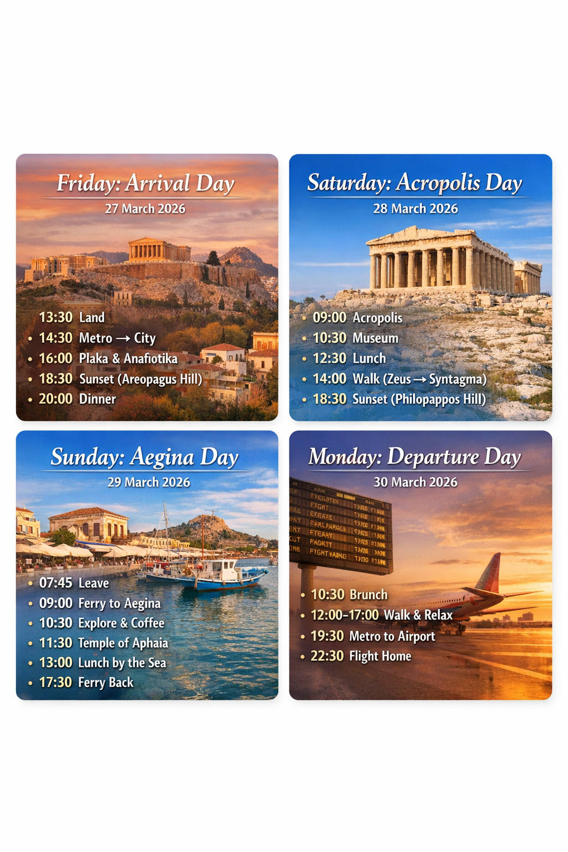

🏛️ Your Athens Itinerary (27–30 March 2026)

✈️ Day 1 – Friday (Arrival + Soft Landing)
Arrival: 13:30 at Athens International Airport Eleftherios Venizelos

🚇 Getting to the city
- Take Metro Line 3 (Blue Line) directly from airport → Acropoli / Syntagma
- Duration: ~40 min
- Cost: ~9€
- Zero stress. No taxi debates. No surprises.

🏡 Check-in
Stay near:
- Acropolis metro area (perfect choice, by the way)

🌇 Afternoon / Evening (easy + beautiful)
Walk it off, don’t rush:
- Plaka (little streets, very “we’re in Greece now”)
- Anafiotika (tiny white houses—feels like a secret island)
- Areopagus Hill sunset
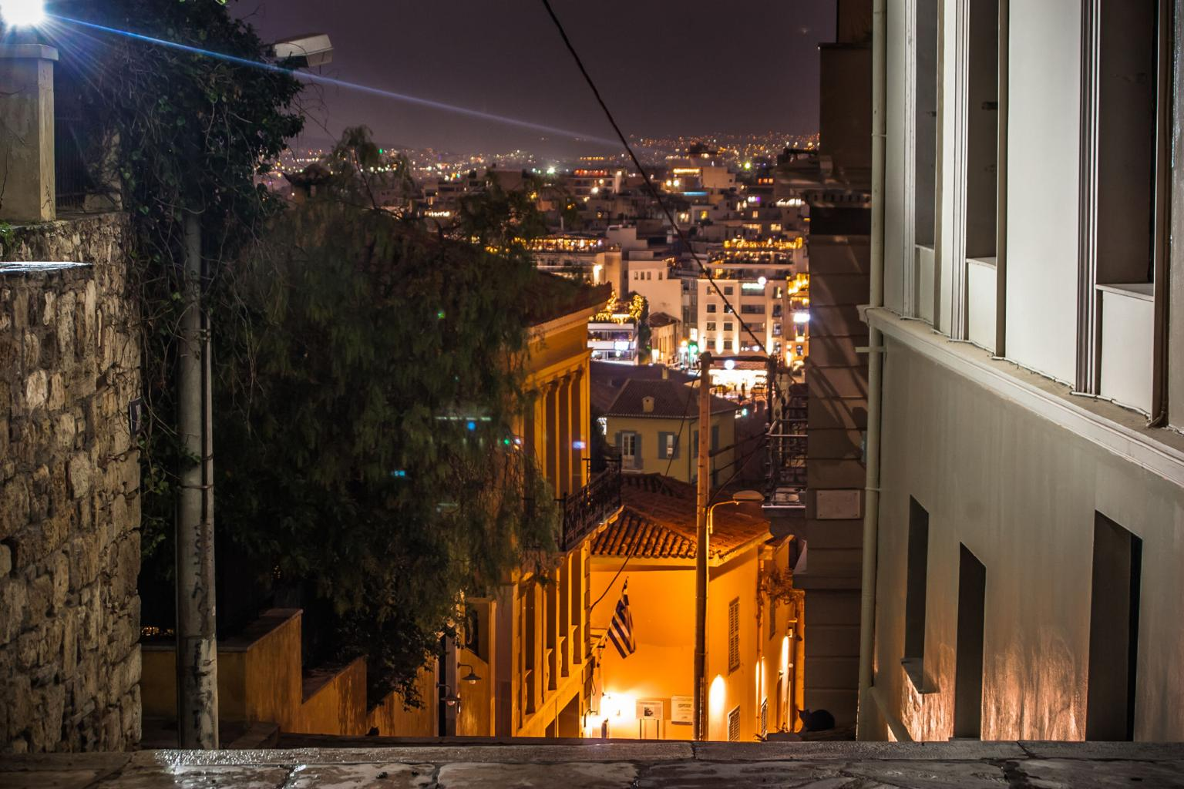
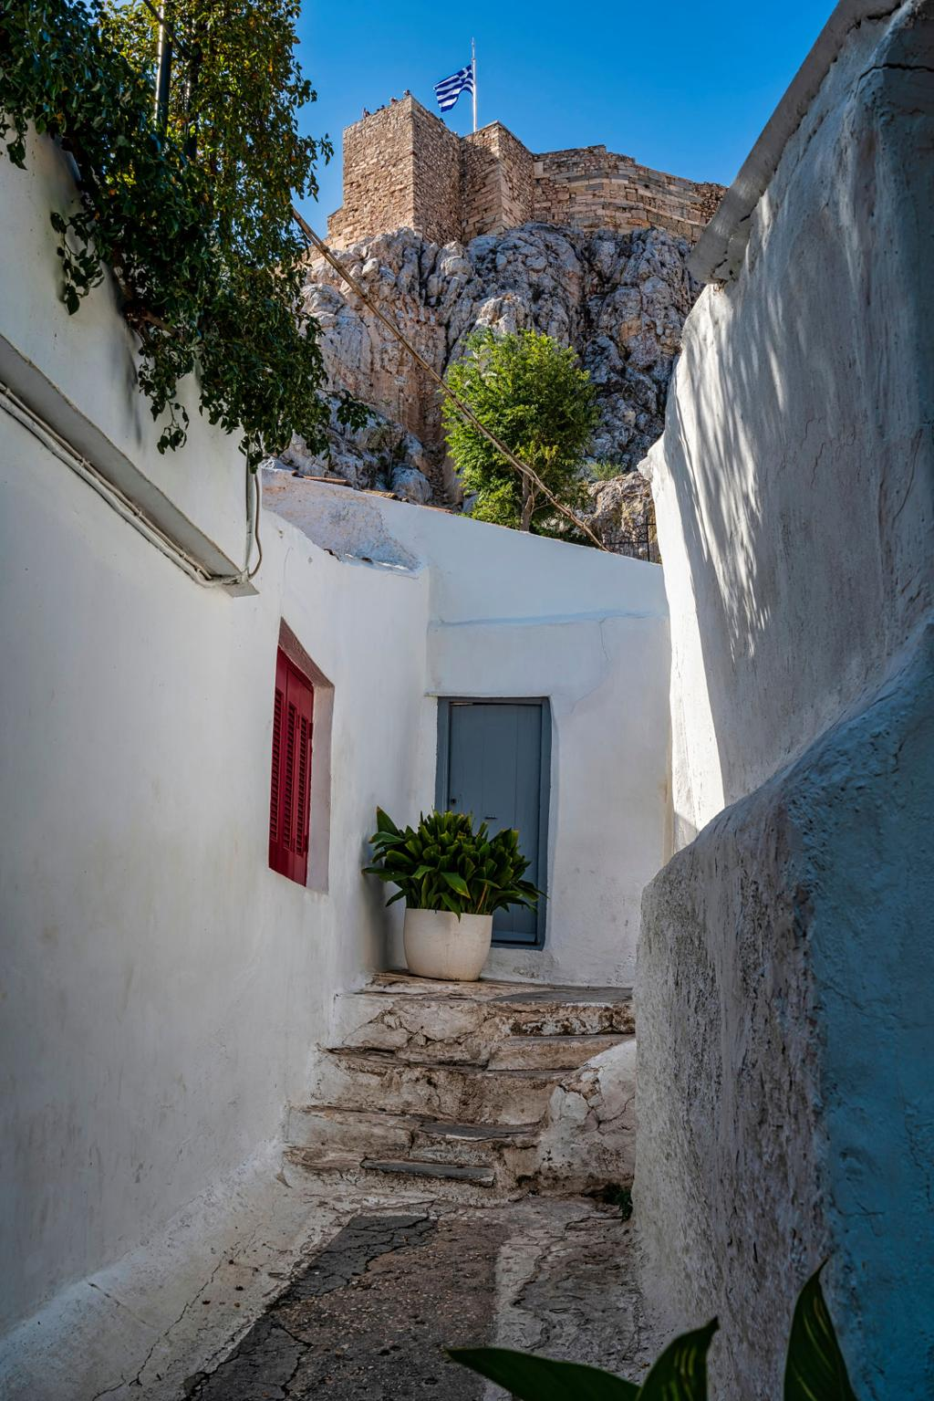
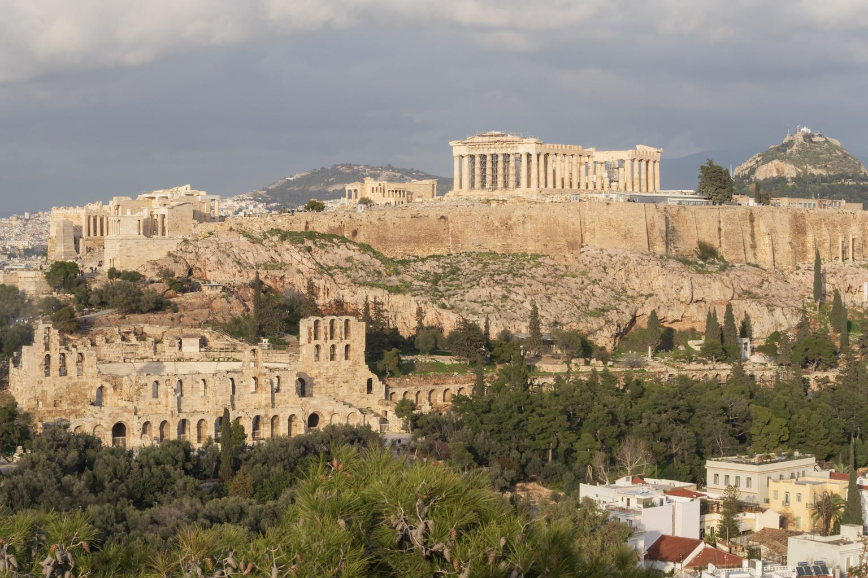

🍽️ Dinner tip
Stay in Plaka/Koukaki area. First night = no experiments, just good Greek food and wine.

🏛️ Day 2 – Saturday (Full Athens Experience)
This is your “tourist but make it iconic” day.

🏛️ Morning: Acropolis
- Acropolis of Athens
- Parthenon
👉 Go early (08:00–09:00). Trust me. By 11:00 it’s a different sport.
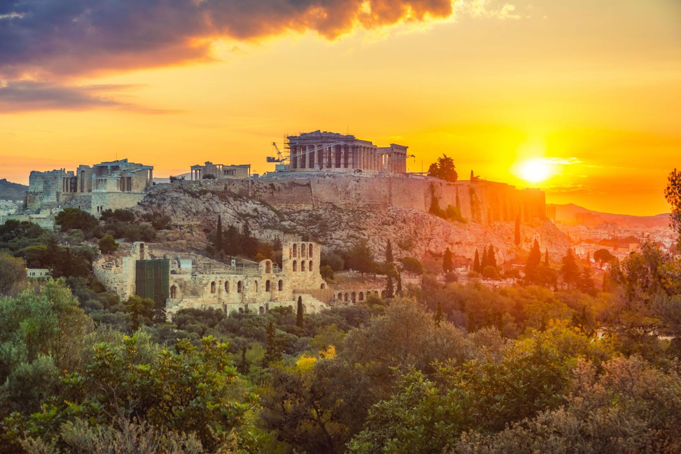
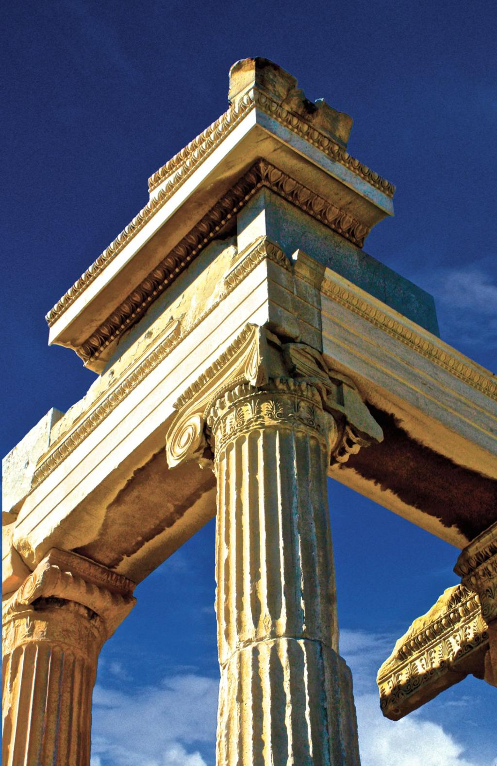
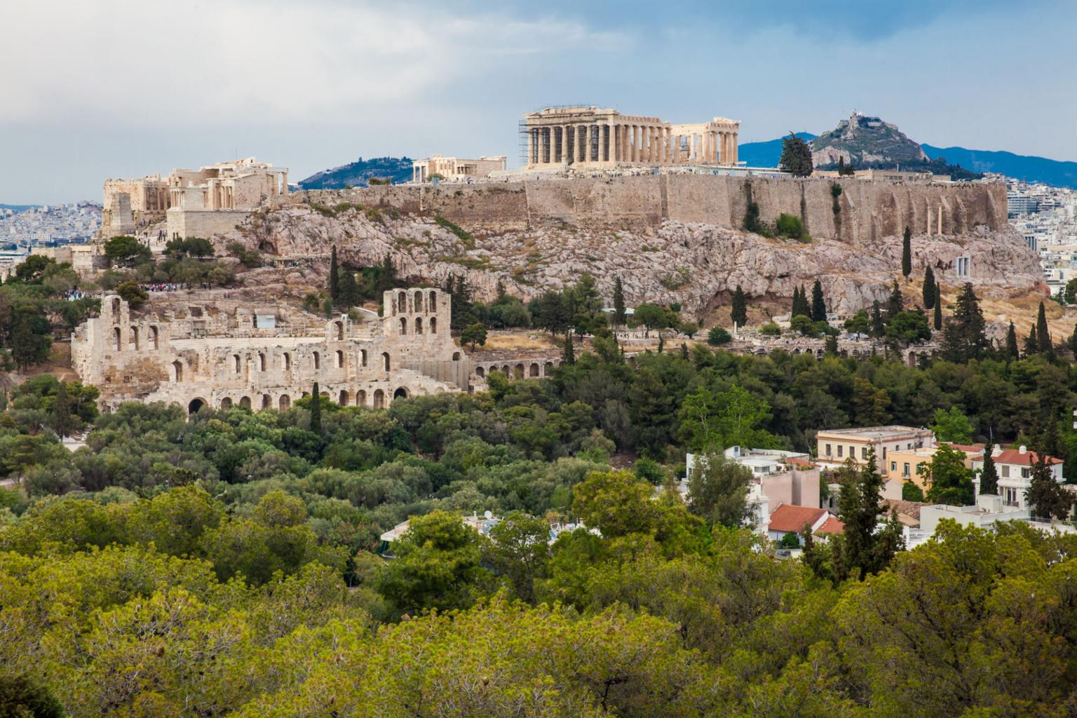

🏛️ Midday: Culture + Coffee
- Acropolis Museum (very worth it)
- Coffee break nearby (you will need it)

🏙️ Afternoon walk route (perfect loop)
All walkable:
- Temple of Olympian Zeus
- Panathenaic Stadium
- Syntagma Square (watch the guards)

🌆 Evening
- Walk Ermou street (shopping + vibe)
- Optional rooftop bar with Acropolis view (worth it once)

🏝️ Your Aegina Day (Sunday, 29 March)

🚢 Ferry Plan (optimized)

➡️ OUTBOUND
- From: Port of Piraeus
- Time: 09:00 (ideal)
- Duration:
  - 🚀 High-speed: ~40 min
  - 🐢 Regular ferry: ~1h10
👉 Take high-speed if available (you gain ~1 extra hour on the island = big win)

⬅️ RETURN
- Target: 17:30–18:30 ferry back
👉 This gives you:
- full relaxed day
- no rushing
- sunset back in Athens if timing aligns

🎟️ Booking (simple + safe)
- Use Ferryhopper
- Book 2–3 days in advance
- Choose:
  - Economy seat
  - no need for upgrades

🗺️ What to do in Aegina (simple but perfect)

📍 Stop 1: Aegina Town (arrival area)
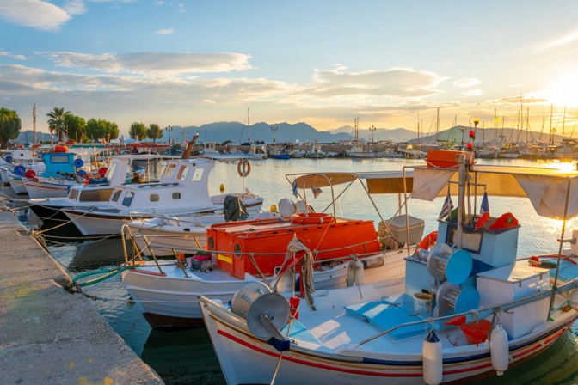
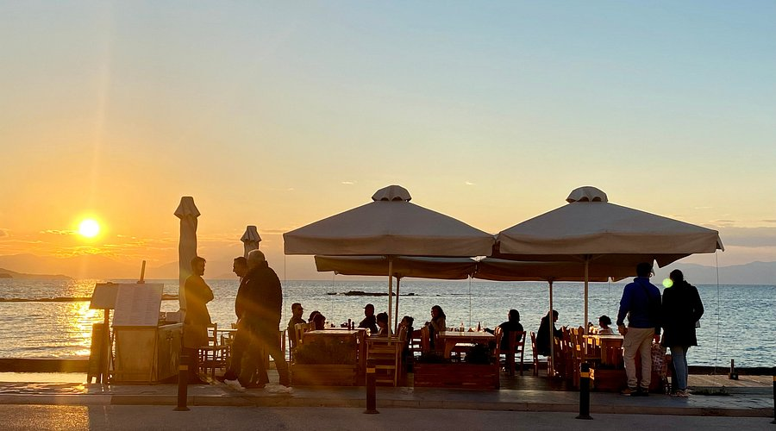
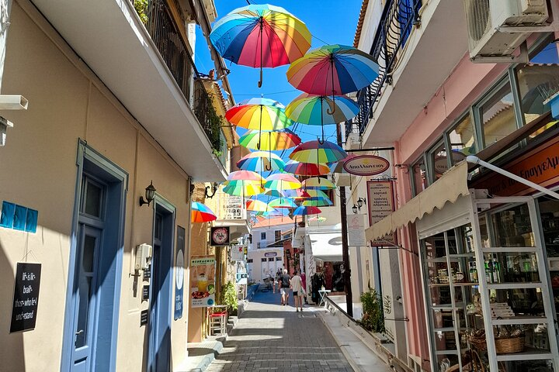

- Walk the harbor
- Grab a coffee
- Buy pistachios (you will anyway, don’t fight it)

🏛️ Stop 2: Temple of Aphaia (hidden gem)
- Temple of Aphaia
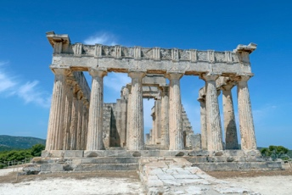
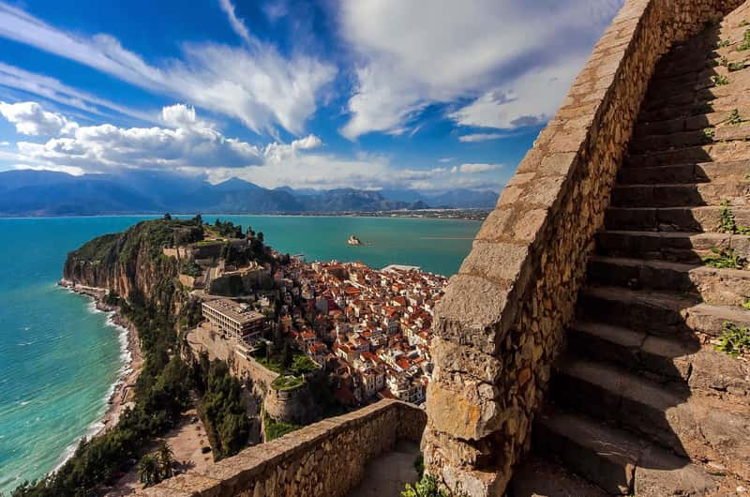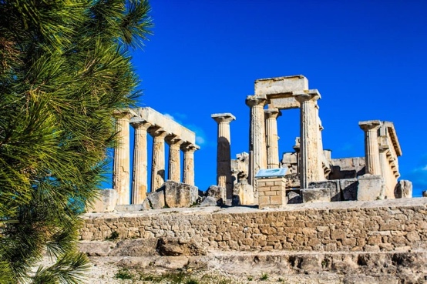

👉 This is your “quiet Acropolis” moment
👉 Less crowded, incredible views
How to get there:
- Taxi (~15–20 min)
- or local bus (cheaper, slightly slower)

🌊 Stop 3: Lunch by the sea

🍽️ Best picks:
- Skotadis Restaurant
👉 classic, right by the water
- To Steki tis Kypselis
👉 more local, less polished, very good
👉 Order:
- grilled fish
- Greek salad
- local wine
- (and yes… pistachio dessert if available)

🚶‍♀️ Optional: walk + chill
- wander small streets
- sit by the water
- do absolutely nothing for 30 minutes (mandatory reset)

🚇 Logistics (super clear)

Morning
- Metro → Piraeus
- Leave apartment: ~07:45–08:00
- Arrive port: ~08:30

Evening
- Ferry back ~18:00
- Metro → Acropolis area
- Dinner near apartment (keep it easy)

✈️ Day 4 – Monday (Flexible + Departure)
Flight: 22:30 → perfect

🧳 Morning (relaxed)
- Brunch in Koukaki (nice + calm area)
- Last souvenirs

🎯 Optional add-ons (pick ONE, don’t overdo it)
- National Archaeological Museum (if you want more history)
- OR revisit favorite area slowly

🚇 Airport transfer
- Metro Line 3 again
- Leave city ~19:30–20:00

⚡ Practical Tips (the difference between chaos & smooth)
- Buy a 3-day tourist transport ticket (~20€)
- Wear GOOD shoes (Athens = beautiful + slippery stones)
- Carry water (seriously)
- Book Acropolis ticket in advance if possible

